Dougy Hérard Pippin Barr Creative Computation I

**Technical Pitch**

Summary

The project aims to implement a very simple animal-like AI. It works conceptually as a Tamagotchi, with the user as an ethereal, and initially foreign, deity that controls the AI’s environment. From a bird’s eye-view, the user sees the pet (which is initially a round blob) and can use different buttons to alter the state of the 8-bit environment, which in turn influences the AI’s evolution.

The user, through mouse and keyboard, influences the pet’s internal attributes. Because the capacities could go a lot of different ways, I want to concentrate on three main interactions through which the user would influence the pet.

* Attract/repulse the pet (depending on relationship built)
* Plant seeds (to create food for pet)
* Play with temperature (this one is thought as optional; for now, the pet’s thermic system would mainly be influenced by food intake.).

Those influence would end up affecting the pet’s internal functioning -- which would technically appear physically in its development; but, for this version, I am aiming to simply have those three attributes (relationship with player, hunger (and sleep), and a semblance of metabolism (to affect whether it ends up warm- or cold-blooded). Having different visible permanent state of the pet would be my next step.

On the following page is the inspiration media found online. They are mainly inspiration for the environment (trees, grass) and the character (Fez, birds). They are all there because there style is attractive to me and they are what I will strive towards in my pixel art for this project.

Media

 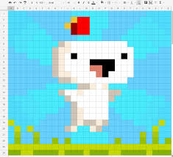

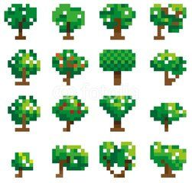

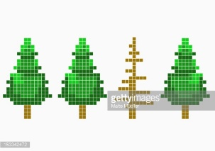

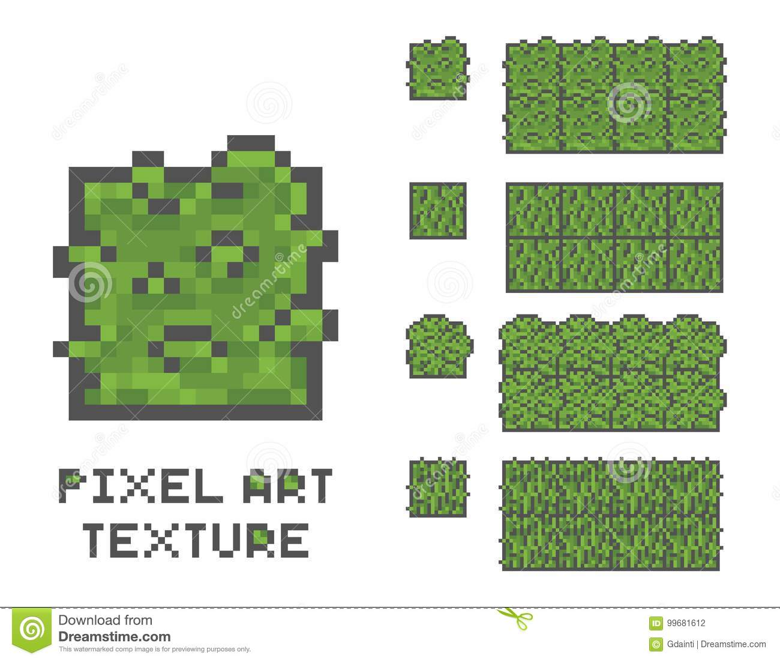

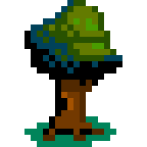 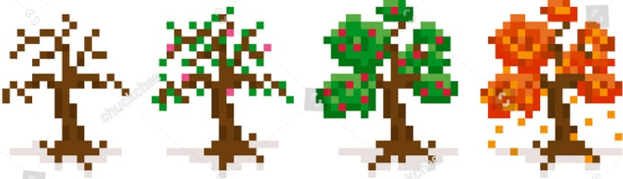 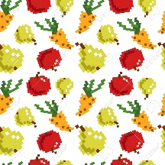

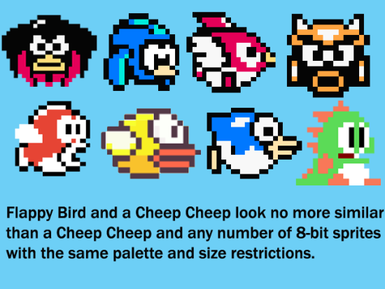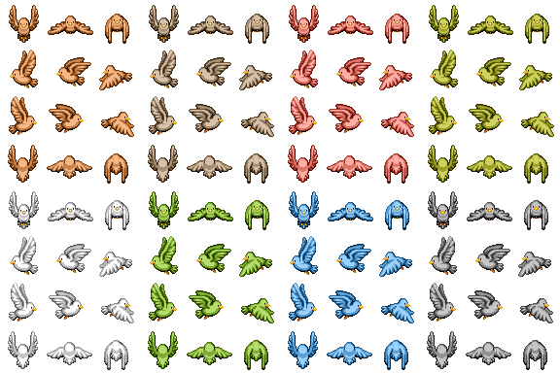

Inspirations

Besides the visual aspect, a big influence on this project is the videogame Spore other simulation game such as the Sims or SimCity. Though what I am doing is on a much smaller scale, it is still heavily influenced by the concept of seeing a lifeform evolve, albeit in a more immediate and non-direct way. Instead of “building” up a creature, the player indirectly affects its development. But, as with the games that influence my project,

Technical approach

The main aspect of this project is that it will simulate an simple AI that seems to take autonomous decision. This will be implemented through a controlled inner randomness that will decide, every x times, what to do with itself depending on its security and its needs. Its security would be foremost, and awaken his *fight or flight* response (although only a flight is planned to be coded this term) whenever in close contact with an unknown entity (e.g. the mouse/user). When secure, it would look whether its need for eating or sleeping is in need of being fulfilled. If not, its reaction would be a simple behaviour to pace time, whether moving, processing information or shivering.

Though I tended to work from scratch, I will add libraries to help me do more in the little time a semester offers. One of those libraries I will use for sure is AI for 2D Games, which will allow me to simply have the pet’s AI in place, as well as its collision with the walls and the trees and its interaction with the player and the objects (e.g. fruits). The class requires me to make children classes of its own class to achieve that effect: I will need a main class for the pet (called *Sentient*) with all of its necessary internal functioning (hunger, sleep, trust, temperature type, wannabe-metabolism variables…), a Tree class and a Fruit class (which should be during its initial stage “children” to its given tree, then become an object of its own).

Technical research

Most of my technical research will be on the library I am using, which is very extensive and will require me some time to master. I will also be using the website Piskel to the visuals.

<http://www.lagers.org.uk/ai4g/index.html>

[www.piskelapp.com](http://www.piskelapp.com)